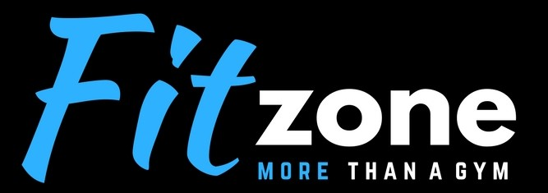

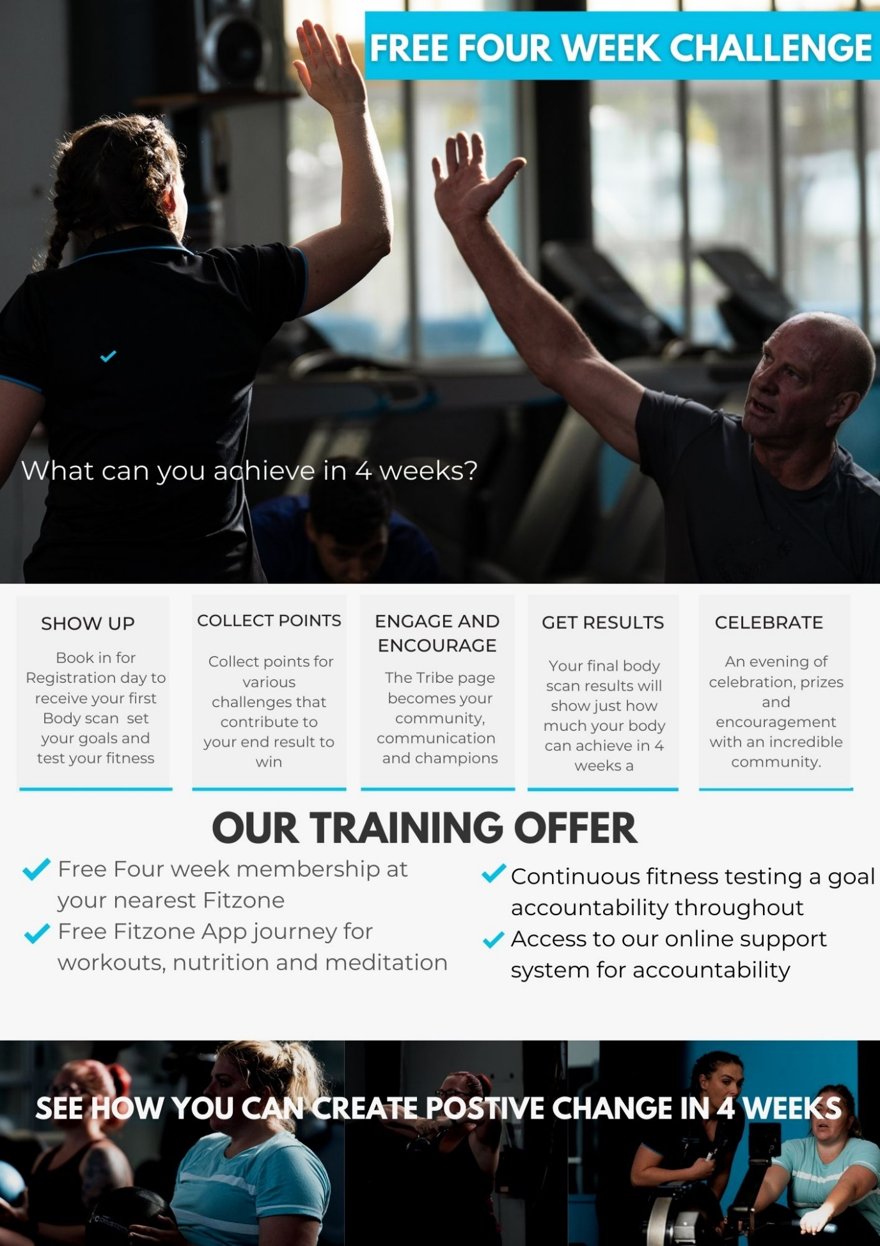<https://www.fitzonenz.com/book-online?utm_source=ActiveCampaign&utm_medium=email&utm_content=Free+Four+Week+Challenge&utm_campaign=Challenge>